DIGITÁLIS RADIOGRÁFIA

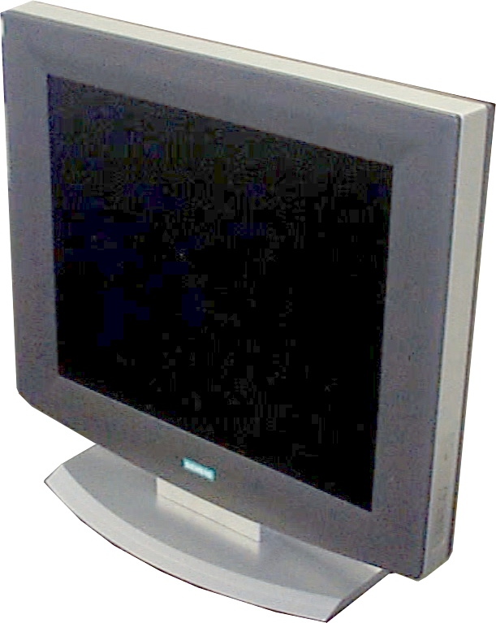
- Screen size: 18” ( = 19”CRT)
- Screen matrix: 1280 x 1024
- Viewing angle: typ. +/- 40°
- Tiltable back and forward
- Gamma correction for optimal display of radiographic grayscale
- Automatic backlight control for long term brightness stability
- Siting up to 5 mT magnetic field

MONITOROK speciális MRI

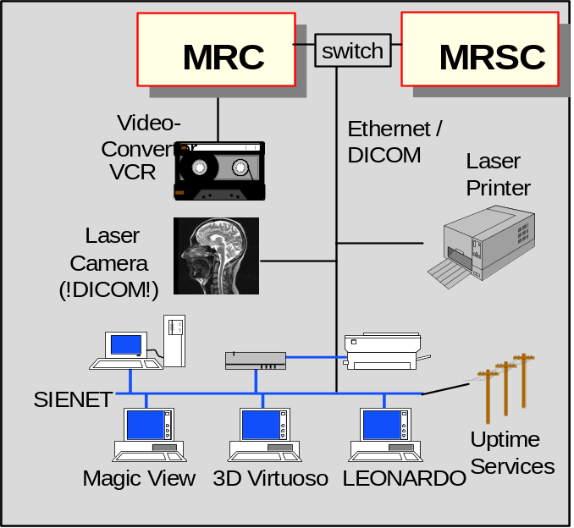

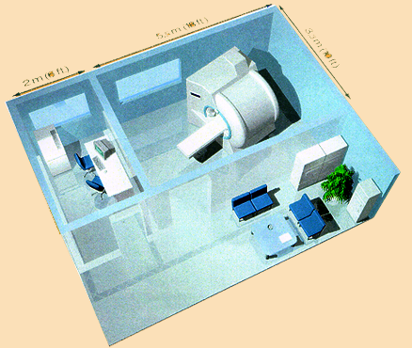

MR telepítés Rendszerkiépítés

Siemens Medical Engineering presents syngo - the new standard for viewing and workstation software


Introduced at RSNA 1999 for

- CT Somatom Plus 4 Volume Zoom
- MR Harmony and Symphony
- Nuclear medicine E.Station
- AX workstation Leonardo
- PACS workstation MagicView 300
- SP Full Field Digital Mammography Workstation (FFDM)

to translate clinical workflows ...
Images
Series
Studies
Quality
Controlled
Images
Patient Data
Request
Worklist
Film Sheets
CD, MOD
Reports
Appointment
Procedure
Description

